1.

SimpleDateFormat dateFormat = new SimpleDateFormat();

dateFormat.format để convert 1 đối tượng Date sang String

dateFormat.parse(String) để convert 1 String sang đối tượng Date

2.

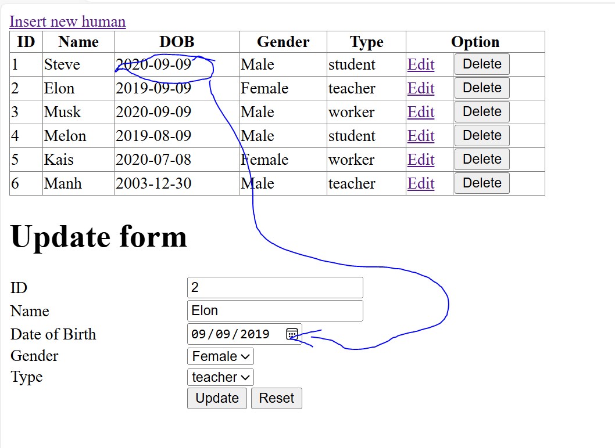

Làm thế nào để đưa string này vào value của <input type=”date”> ?

=> let dobInput = form.querySelector("input[name='dob']");

dobInput.value = new Date(dob).toISOString().substring(0, 10); // Format date to YYYY-MM-DD

Explain:

• **Input Value:** dob= "2020-09-09"

• **Step-by-Step:**

1. new Date("2020-09-09") creates a Date object representing September 9, 2020.
2. new Date("2020-09-09").toISOString() converts this to "2020-09-09T00:00:00.000Z".
3. "2020-09-09T00:00:00.000Z".substring(0, 10) extracts "2020-09-09".

In HTML, the input element with type="date" expects the value in the format YYYY-MM-DD regardless of how the date might be displayed in the browser based on locale settings. Browsers can display the date in various formats (e.g., MM/DD/YYYY, DD/MM/YYYY, etc.) based on the user's locale or system settings